AI – 10/6

Interesting how fraction of SAT problems that are solvable has dramatic threshold at around 4.3\*number of atoms – possibly related to thresholds for existence of a clique in a random graph?

Predicate Calculus/First order logic:

Relation between entities

Predicates apply to term

Term = constant, variable, function

Also, quantifiers $∀, ∃$

Domain of entities: suppose yo define the domain to be a “thing”

Const is a thing

Var are in thing

Fn, Pred—relations over thing

Syntax of predicate calculus:

Non-logical symbols:

- constants (SAM, 1) ->entities

- function symbols (+) -> mappings

- predicate symbols -> relations –child(a,b), <=(a,b)

Logical Symbols:

* Boolean operators (not, and, or, =>, <=)
* quantifiers ($∀, ∃$)
* variable
* Grouping: () – or association

Term ::= const | var| Fn(Term,…,Term)

AtomFormula ::= Pred(Term,…,Term)

Formula ::= AtomFormula | ~ Formula | (Formula bool formula) | quant var formula

A sentence is a formula with no unbound variables – every variable has an associated quantifier

$$∀x, x is a vegetarian<->\sim ∃meat\left(y\right) AND eats(x,y)$$

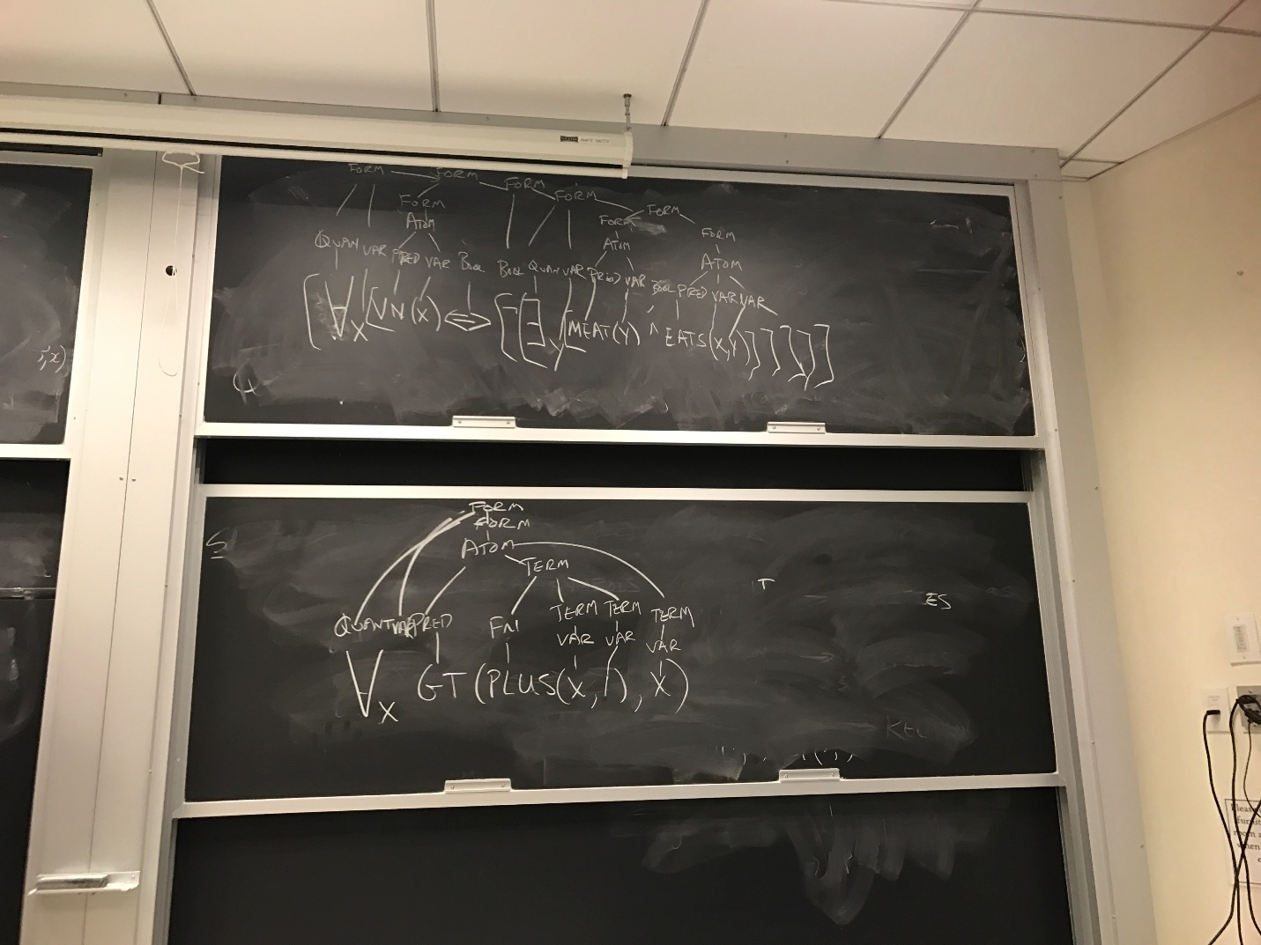

Predicates:

Cant have Pred(Pred | bool | quant)

Can’t have Fn(pred)

Ex: sam has a male child:

Wrong:

Male(there exists x child(x,sam))

Right:

There exists x male(x) AND chile(x,Sam)

Ex: mary and ed and married to one another:

Wrong: married(Ed) AND married(Mary) –says they are each married to someone

Right: married(mary, ed)

All P’s are Q’s

For all x, P(x) => Q(x), or equivalently Q(x) OR ~P(x)

There exists x, P(x) AND Q(x)

Problems translating from english:

If someone is 18 then they can vote --- should really be if ANYONE is 18, they can vote

If a person has a license, then they can drive – should be if ANYONE has a license …

The following are equivalent:

If P then Q

Q if P

P only if Q

Inference Problem:

Given a set of sentences and a proposed conclusion, want to show if conclusion is a logical consequence of our sentence.

This problem is semi-decidable:

There is an algorithm such that if gamma implies phi, it returns true. But if not, algorithm may return false, but it may get stuck in an infinite loop.

Resolution Theorem proving:

RTP(gamma, phi){

Delta = gamma OR {not phi)

Convert delta to CNF

Loop: while (TRUE){

Either {

choose 2 sentences in delta (a,b)

apply rule of resolution to a,b – giving gamma

add gamma to delta

}

OR{

Choose alpha from delta, apply rule of factoring to alpha, giving new sentence gamma

Add gamma to delta

}

if (gamma == NULL)

return(true);

if (cannot derive any more clauses)

return(false);

}

}

It is possible that the loop never ends, because there are always more clauses to be derived, without returning null.

Getting rid of existential quantifiers:

Suppose we have “some crows are black”

There exists an x such that crow(x) and black(x)

SKOLEMIZATION:

Come up with new skolem constant, substitute for variable

Crow(skl) AND black(skl)

Suppose existential quantifier is in universal quantifier:

“For all x, there exists a y such that x>y”

In this case, the y we need depends on x, i.e it is a function: a SKOLEM FUCNTION